

VOLUNTARY NON-REMUNERATED BLOOD DONATION

DETAIL DESIGN DOCUMENT

Data Design

**Project Code: VNBD**

**Document Code: VNBD_Data Design_v1.0_EN**

**Ha Noi, 23/09/2013**

Record of change

*A - Added M - Modified D – Deleted

|  |  |  |  |  |
| --- | --- | --- | --- | --- |
| Effective Date | Changed Items | A* M, D | Change Description | New Version |
| 23/09/2013 | Add new | A |  | v0.1 |
| 30/09/2013 | Modified | M | Update comments of supervisor | v0.9 |
| 20/10/2013 | Modified | M | Update comments of supervisor | v0.9.9 |
| 23/10/2013 | Modified | M | Update version | v1.0 |
|  |  |  |  |  |
|  |  |  |  |  |
|  |  |  |  |  |
|  |  |  |  |  |
|  |  |  |  |  |
|  |  |  |  |  |

SIGNATURE PAGE

**ORIGINATOR:** Nguyen Manh Cuong 23/09/2013

Developer

**REVIEWERS:** Nguyen Thi Tam 30/09/2013

Tester

Ngo Tran Linh 09/10/2013

PM

**APPROVAL:** Bui Dinh Chien 23/10/2013

Supervisor

TABLE OF CONTENTS

1 Introduction 5

1.1 Purpose 5

1.2 Definitions, Acronyms and Abbreviations 5

1.3 References 5

1.4 Overview 6

2 Database 7

2.1 ERDs 7

2.2 Description Entity 9

2.2.1 User entity 9

2.2.2 Comment entity 11

2.2.3 Resource entity 11

2.2.4 QA entity 12

2.2.5 Post entity 12

2.3 Table Database 13

2.3.1 Vnbd_user table 14

2.3.2 Vnbd_comment table 16

2.3.3 Vnbd_resource table 17

2.3.4 Vnbd_qa table 19

2.3.5 Vnbd_post table 20

3 File design 22

4 Code Design 23

4.1 Customer Code 23

5 Other considerations 24

6 Appendix 25

6.1 Data format symbol 25

# Introduction

## Purpose

Voluntary non-remunerated blood donation data design document describes structure of database and file structure of system including internal file structure as well as interface file structure.

## Definitions, Acronyms and Abbreviations

|  |  |  |
| --- | --- | --- |
| Abbreviations | Description | Comment |
| PK/FK | Primary/ Foreign key | Use to indicate that a field is a primary or foreign key in table |
| V | Check value null | Set value “null” for attribute in table |

## 

## References

List the entire reference document such as: other document of the system, or the technical article.

|  |  |
| --- | --- |
| Document Number | Title |
| VNBD_ Class design_v1.0_EN | N/A |
| VNBD_ Screen design_v1.0_EN | N/A |

## Overview

General overview of the detail design such as what is the structure of the document: N/A

# Database

## ERDs

Entity relationship diagrams

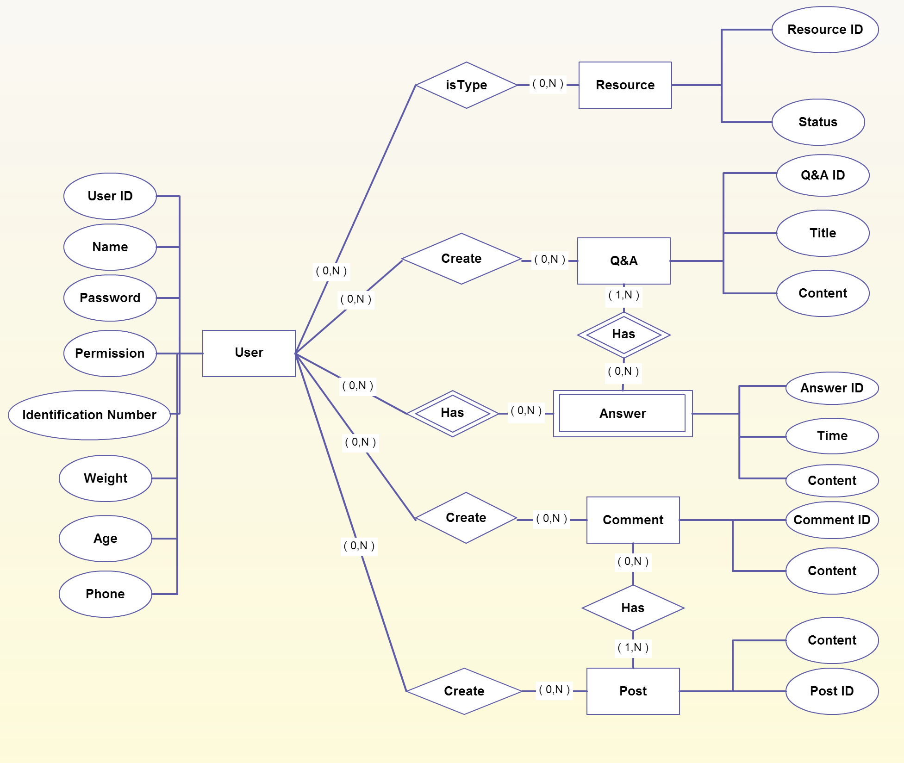

**Figure 1: Entity relationship diagrams**

|  |  |  |
| --- | --- | --- |
| **No** | **Entity** | **Description** |
| 1 | User | User is all of people of website who register to become member. |
| 2 | Resource | Resource is all of member who registered donating or receiving blood. |
| 3 | QA | QA is question of member to other people can answer. |
| 4 | Answer | Answer is only reply for QA from member in website. |
| 5 | Comment | Comment is only remark of member for posts. |
| 6 | Post | Post is news which created member of admin in website. |

List of relations of entities and brief description

|  |  |  |  |  |
| --- | --- | --- | --- | --- |
| **No** | **Entity A** | **Entity B** | **Relation** | **Description** |
| 1 | User | Resource | One to many | User can become people who donate or receive blood many times |
| 2 | User | QA | One to many | Each User can create many QAs |
| 3 | User | Answer | One to many | Each User can answer to respond many QAs |
| 4 | User | Comment | One to many | Each User can comment below the post |
| 5 | User | Post | One to many | Each User can create a post for donating or receiving blood |
| 6 | QA | Answer | One to many(weak) | Each QA has many answer from users |
| 7 | Post | Comment | One to many | Each post has many comment form users |

## Description Entity

### User entity

|  |  |  |  |  |  |  |  |  |  |
| --- | --- | --- | --- | --- | --- | --- | --- | --- | --- |
| No | Field Name | Type | Length | Size | Null | Unique | P/F Key | Default | Description |
|  | id | Int | 5 |  |  |  | P |  | PRIMARY KEY  This is automatically increase value 1 |
|  | name | Varchar |  |  |  |  |  |  | User’s display name |
|  | password | Varchar | 32 |  |  |  |  |  | Store password login of user.  Using md5 algorithm. |
|  | permission | Varchar | 30 |  |  |  |  |  | Admin can assign permission for user |
|  | type_blood_user | Varchar | 10 |  | V |  |  |  | Type blood of user(check null because user still doesn’t know their type blood) |
|  | description | Text |  |  | V |  |  |  | User can provide more information about them |
|  | avatar | Varchar | 50 |  | V |  |  |  | User’s picture |
|  | phone | Varchar | 15 |  |  |  |  |  | User’s mobiphone |
|  | gender | Varchar | 1 |  |  |  |  |  | User’s gender |
|  | identification_number | Int | 20 |  |  |  |  |  | User’s identification number |
|  | email | Varchar | 50 |  |  |  |  |  | User’s email |
|  | age | Int | 2 |  |  |  |  |  | User’s age |
|  | birthday | Date |  |  |  |  |  |  | User’s birthday |
|  | job | Text |  |  | V |  |  |  | User’s job |
|  | address | Text |  |  |  |  |  |  | User’s address |
|  | weight | Int |  |  |  |  |  |  | User’s weight |

### Comment entity

|  |  |  |  |  |  |  |  |  |  |
| --- | --- | --- | --- | --- | --- | --- | --- | --- | --- |
| No | Field Name | Type | Length | Size | Null | Unique | P/F Key | Default | Description |
|  | id | Int | 5 |  |  |  | P |  | PRIMARY KEY  This is automatically increase value 1 |
|  | content_cmt | Text |  |  |  |  |  |  | Content of comment |

### Resource entity

|  |  |  |  |  |  |  |  |  |  |
| --- | --- | --- | --- | --- | --- | --- | --- | --- | --- |
| No | Field Name | Type | Length | Size | Null | Unique | P/F Key | Default | Description |
|  | Id | Int | 5 |  |  |  | P |  | PRIMARY KEY  This is automatically increase value 1 |
|  | status | Tinyint | 1 |  |  |  |  |  | Available or not available of User: donating or receiving blood |

### QA entity

|  |  |  |  |  |  |  |  |  |  |
| --- | --- | --- | --- | --- | --- | --- | --- | --- | --- |
| No | Field Name | Type | Length | Size | Null | Unique | P/F Key | Default | Description |
|  | Id | Int | 5 |  |  |  | P |  | PRIMARY KEY  This is automatically increase value 1 |
|  | content_qa | Text |  |  |  |  |  |  | Content QA |

### Post entity

|  |  |  |  |  |  |  |  |  |  |
| --- | --- | --- | --- | --- | --- | --- | --- | --- | --- |
| No | Field Name | Type | Length | Size | Null | Unique | P/F Key | Default | Description |
|  | id | Int | 5 |  |  |  | P |  | PRIMARY KEY  This is automatically increase value 1 |
|  | title_pst | Text |  |  |  |  |  |  | Title of post |
|  | content_pst | Text |  |  |  |  |  |  | Content of post |

## Table Database

## 

n

**Figure 2: Table diagram**

List of tables and brief description

|  |  |  |
| --- | --- | --- |
| No | Table Name | Description |
|  | vnbd_user | Store all user information. |
|  | vnbd_comment | Store all information in comment of each user. |
|  | vnbd_ resource | Store all information of users who want to receive blood and donate blood. |
|  | vnbd_qa | Store all questions and answers from users. |
|  | vnbd_post | Store all information of articles, activities. |

### Vnbd_user table

|  |  |  |  |  |  |  |  |  |  |
| --- | --- | --- | --- | --- | --- | --- | --- | --- | --- |
| No | Field Name | Type | Length | Size | Null | Unique | P/F Key | Default | Description |
|  | id | Int | 5 |  |  |  | P |  | PRIMARY KEY  This is automatically increase value 1 |
|  | name | Varchar |  |  |  |  |  |  | User’s display name |
|  | password | Varchar | 32 |  |  |  |  |  | Store password login of user.  Using md5 algorithm. |
|  | permission | Varchar | 30 |  |  |  |  |  | Admin can assign permission for user |
|  | type_blood_user | Varchar | 10 |  | v |  |  |  | Type blood of user(check null because user still doesn’t know their type blood) |
|  | description | Text |  |  | V |  |  |  | User can provide more information about them |
|  | avatar | Varchar | 50 |  | V |  |  |  | User’s picture |
|  | phone | Varchar | 15 |  |  |  |  |  | User’s mobiphone |
|  | gender | Varchar | 1 |  |  |  |  |  | User’s gender |
|  | identification_number | Int | 20 |  |  |  |  |  | User’s identification number |
|  | email | Varchar | 50 |  |  |  |  |  | User’s email |
|  | age | Int | 2 |  |  |  |  |  | User’s age |
|  | birthday | Date |  |  |  |  |  |  | User’s birthday |
|  | job | Text |  |  | v |  |  |  | User’s job |
|  | address | Text |  |  |  |  |  |  | User’s address |
|  | weight | Int |  |  |  |  |  |  | User’s weight |
|  | created | datetime |  |  |  |  |  |  | Time when user’s account is created |
|  | modified | datetime |  |  |  |  |  |  | Time when user’s account is modified |
|  | updated | datetime |  |  |  |  |  |  | Time when user’s account is updated |

### Vnbd_comment table

|  |  |  |  |  |  |  |  |  |  |
| --- | --- | --- | --- | --- | --- | --- | --- | --- | --- |
| No | Field Name | Type | Length | Size | Null | Unique | P/F Key | Default | Description |
|  | id | Int | 5 |  |  |  | P |  | PRIMARY KEY  This is automatically increase value 1 |
|  | id_user | Int | 5 |  |  |  | F |  | ID user to refer |
|  | id_post | Int | 5 |  |  |  | F |  | ID post to refer |
|  | content_cmt | Text |  |  |  |  |  |  | Content of comment |
|  | created | datetime |  |  |  |  |  |  | Time when user’s comment is created |
|  | modified | datetime |  |  |  |  |  |  | Time when user’s comment is modified |
|  | updated | datetime |  |  |  |  |  |  | Time when user’s comment is updated |

### Vnbd_resource table

|  |  |  |  |  |  |  |  |  |  |
| --- | --- | --- | --- | --- | --- | --- | --- | --- | --- |
| No | Field Name | Type | Length | Size | Null | Unique | P/F Key | Default | Description |
|  | id | Int | 5 |  |  |  | P |  | PRIMARY KEY  This is automatically increase value 1 |
|  | id_user | Int | 5 |  |  |  | F |  | ID user to refer |
|  | status | tinyint | 1 |  |  |  |  |  | Available or not available of User: donating or receiving blood |
|  | donor | Int | 5 |  |  |  |  |  | Store user ID want to donate blood |
|  | receiver | Int | 5 |  |  |  |  |  | Store user ID want to receive blood |
|  | description | Text |  |  | v |  |  |  | Reason of receiver needs blood |
|  | created | datetime |  |  |  |  |  |  | Time when receiver’s information is created |
|  | modified | datetime |  |  |  |  |  |  | Time when receiver’s information is modified |
|  | updated | datetime |  |  |  |  |  |  | Time when receiver’s information is updated |

### Vnbd_qa table

|  |  |  |  |  |  |  |  |  |  |
| --- | --- | --- | --- | --- | --- | --- | --- | --- | --- |
| No | Field Name | Type | Length | Size | Null | Unique | P/F Key | Default | Description |
|  | id | Int | 5 |  |  |  | P |  | PRIMARY KEY  This is automatically increase value 1 |
|  | id_user | Int | 5 |  |  |  | F |  | ID user to refer |
|  | title_qa | Text |  |  |  |  |  |  | Title of QA |
|  | content_qa | Text |  |  |  |  |  |  | Content QA |
|  | created | Datetime |  |  |  |  |  |  | Time when user’s QA is created |
|  | modified | Datetime |  |  |  |  |  |  | Time when user’s QA is modified |
|  | updated | Datetime |  |  |  |  |  |  | Time when user’s QA is updated |

### Vnbd_post table

|  |  |  |  |  |  |  |  |  |  |
| --- | --- | --- | --- | --- | --- | --- | --- | --- | --- |
| No | Field Name | Type | Length | Size | Null | Unique | P/F Key | Default | Description |
|  | Id | Int | 5 |  |  |  | P |  | PRIMARY KEY  This is automatically increase value 1 |
|  | id_user | Int | 5 |  |  |  | F |  | ID user to refer |
|  | title_pst | Text |  |  |  |  |  |  | Title of post |
|  | content_pst | Text |  |  |  |  |  |  | Content of post |
|  | created | Datetime |  |  |  |  |  |  | Time when user’s post is created |
|  | modified | Datetime |  |  |  |  |  |  | Time when user’s post is modified |
|  | updated | Datetime |  |  |  |  |  |  | Time when user’s post is updated |

# File design

N/A

# Code Design

N/A

## Customer Code

N/A

# Other considerations

N/A

# Appendix

## Data format symbol

Following symbols are used to describe format of data field in files as well as in tables.

|  |  |
| --- | --- |
| Symbol | Description |
| # | Digit placeholder. |
| . | Decimal placeholder. |
| , | Thousands separator. |
| : | Time separator. |
| / | Date separator. |
| \ | Treat the next character in the mask string as a literal. This allows you to include the '#', '&', 'A', and '?' characters in the mask. This character is treated as a literal for masking purposes. |
| > | Convert all the characters that follow to uppercase. |
| < | Convert all the characters that follow to lowercase. |
| A | Alphanumeric character placeholder (entry required). For example: a – z, A – Z, or 0 – 9. |
| A | Alphanumeric character placeholder (entry optional). |
| 9 | Digit placeholder (entry optional). For example: 0 – 9. |
| 0 | Digit placeholder (entry required). For example: 0 – 9. |
| C | Character or space placeholder (entry optional). Valid values for this placeholder are ANSI characters in the following ranges: 32-126 and 128-255. |
| & | Character placeholder (entry required). Valid values for this placeholder are ANSI characters in the following ranges: 32-126 and 128-255. |
| ? | Letter placeholder. For example: a – z or A – Z. |
| Literal | All other symbols are displayed as literals; that is, as themselves. bound in “” like “ABC” |